

MIDDLE EAST TECHNICAL UNIVERSITY

DEPARTMENT OF

ELECTRICAL AND ELECTRONICS

ENGINEERING

EE568 - Special Topics on Electrical Machines

Project #4

Analysis and Design of SMPM Machine for Servo Application

28/06/2020

Raşit GÖKMEN – 2339760

# Contents

1. Contents 2

2. Introduction 3

3. Analytical Calculation and Sizing 3

3.1. Choosing the Specific Machine Constant 3

3.2. Selection of suitable wire cable 5

3.3. Calculation of slot height, number of coils per slot and back-core thickness 5

3.4. Electric loading calculation 6

3.5. Calculation of force and tangential stress 6

3.6. Calculation of output power of the machine 7

4. Comparison and Optimization 7

4.1. Optimum rotor diameter and slot ratio for maximum torque output 7

4.2. Changing magnet material with ferrite and comparison 10

4.3. Optimization of Ferrite machine 11

5. Conclusion 14

# Introduction

Servo motors are widely used in many industrial applications that reqiure precise control of speed and position. Some applications where servo motors are used are robotics, rolling machines, antenna positioning etc. There are many type of servo motors such as DC motors, brushless DC motor, PMSMs. AC PMSM servo motors are widely used for servo applications for their higher torque ouput, higher efficiency. There are many different PMSM topology but the main two topology are Interior Permanent Magnet Synchronous Machine (IPMSM) and Surface-Mounted Permanent Magnet Synchronous Machine (SMPMSM).

# Analytical Calculation and Sizing

In this part, analytical calculation will be given in order to choose roughly size and dimension of the machine. The specifications of the machine is given below:

* **Machine Type:** Surface-Mounted Permanent Magnet Synchronous Machine
* **Rated Output Power:** 1 kW
* **Rated Voltage:** 400 Vl-l
* **Rated Speed:** 3000 rpm
* **Rated Torque:** 3.18 N.m
* **Instantaneous Peak Torque:** 9.54 N.m
* **Rated Current:** 2.8 Arms
* **Enclosure:** Totally enclosed, self-cooled, IP67
* **Duty Type:** Continuous Operation
* **Ambient Temperature:** 0-40 ֯C

## Choosing the Specific Machine Constant

In this part, the specific machine constant, C is choosen by selecting appropriate electrical and magnetic loading parameter for the machine.

The specific machine constant can be written as,

where, .

A is the rms value of the linear current density.

is the peak air-gap flux density.

is the fundamental component of the winding factor.

For initial design, is selected as 0.955. In Figure 1, electrical loading, magnetic loading and tangential stress values are given for different motor types. For this design, which is a nonsalient-pole synchronous machine with air cooling, electrical loading value is given between 30-80 kA/m and magnetic loading given 0.8-1.05 T. From Figure 1., Linear current density and peak air-gap flux density are choosen as 50 kA/m, rms and 1 T, respectively.

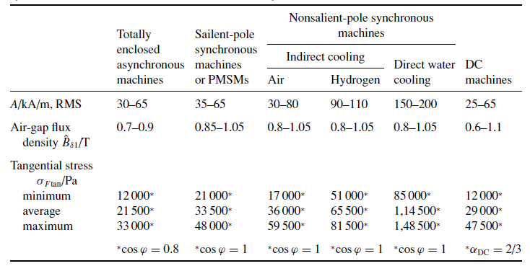

Figure 1. Electrical loading, magnetic loading and tangential stress values for different motor types [kitap]

By using choosen values, the specific machine constant calculated as,

For servo motor application, low inertia is requirred for high dynamic performance. In order to obtain low inertia, smallar diameter is choosen. Therefore, aspect ratio is chosen as 1.5.

= 1.5

D =

Which yields axiel length L’ = 51.3 mm

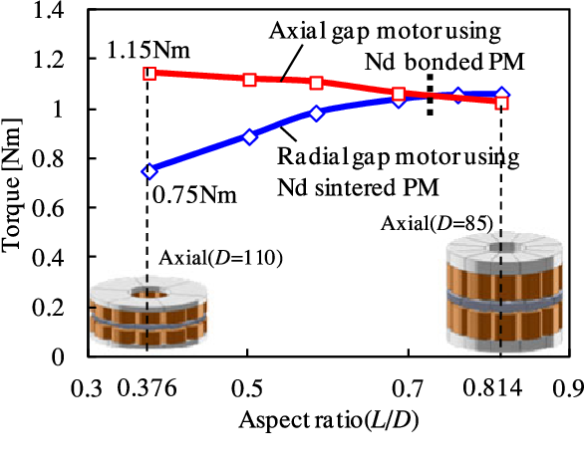

Figure 2. Aspect ratio versus Torque output graph for axial flux and radial flux machines [ozan hoca not]

The air-gap clearance can be calculated by using following formula

For converter driven motors air-gap can be increased by 60% to reduce rotor surface losses. Therefore, air-gap clearance is increased to 0.45mm.

In this machine one of aims is the high efficiency. Therefore, low number of pole is better for this design. Because, as we know stator iron losses increases proportional to number of poles. On the other hand, low number of poles means higher stator back-core flux density which requires higher stator outer diameter if the rotor diameter fixed. For our design, stator outer diameter can be increased because efficiency is more important for us. Therefore, for initial design number of pole is choosen as 4.

(12)

where, q: number of slots per phase per pole

p: number of poles

m: number of phases

If q is choosen as 1, it means the windings are concentared which is not prefable for harmonic content of mmf distribution and resultant induced voltages. Therefore, q has to be greater than 1. As the q increases, the harmonic content of mmf waveform reduces but on the other hand the cost of manufacturing these slots on the core increases due to increased insulation need and stamping operation. Also, as the number of slots increases, for constant stator inner diameter, the width of teeth and slot decreases and they should not be smaller than the mechanical limits otherwise there will be a tooth bending and/or breakage. Lets choose, q as 2. This will yields number of slots as 24.

The machine has 2.8 Arms rated current for rated torque. But it should be work at peak torque which is equal to 3 times of rated torque. Therefore we need to select wire size by considering this peak torque. The wire current rating must be greater than 8.4Arms.

For self-cooled SMPM motor, current density is selected as 4 A/mm2. For this current density value we need a wire with area of at least 2.1 mm2. AWG#14 wire size is selected which has 2.08 mm2 wire size which is applicable for our design.

For this slot number tooth thickness is found as,

= = 2.82 mm (13)

where, slot width ratio is assumed as 0.5.

stator circumference:

Inner stator diameter can be calculated by adding rotor outer diameter, 2 times magnet thickness and air-gap clearances:

where, magnet thickness is assumed as 4mm.

In this part, slot height, number of coils per slot and back-core thickness are calculated. To calculate slot height, slot ratio is choosen. Slot ratio(d) is the ratio of inner stator slot diameter to outer stator slot diamater. Larger slot ratio means smaller slot height and as the slot ratio reduces slot height increases and hence electrical loading increases for the same diameter. It is assumed that we have parallel teeth in our design which is most common design of stator tooth. By the help of parallel teeth slot gets wider with diameter which enables us to use put more coils into the slot. In the class it was shown that for ‘thin’ parallel teeth slot ratio, d has the optimum value of 0.6. Therefore, slot ratio is choosen as 0.6.

Outer stator slot diamater, Do can be calculated as,

(15)

where, Di is the inner stator slot diamater.

If, slot width ratio is assumed as 0.5, inner slot width becomes,

(39)

And outer slot width becomes,

(40)

And slot height, is equals to,

(41)

For the open slot type and rectangular teeth shape, slot area, Aslot can be calculated as,

(42)

Then, number of coils per slot can be calculated as,

(18)

The back-core flux is equal to half of the flux per pole.

(19)

where, is assumed as the saturation flux density for the stator iron Bsat of 1.5 T.

where, Di: rotor diamater

L: axial length of the motor

p: number of poles

Magnet to Pole Pitch Ratio assumed as 0.8.

can be written as,

(20)

where, is the back-core thickness

is the stacking factor of the core which is assumed 0.95.

is the axial core length

The back-core thickness for the maximum flux density at the stator back-core be calculated as,

(21)

Stator outer diameter, D can be calculated as,

# Conclusion